**Lab Task 9**

**Numerical Computing Lab(105127)**

**Ali Afzal(63961)**

Q1:

Code:

from numpy import np

ITERATION_LIMIT = 1000

A = np.array([[10.,-1.,2.,0.],

[-1.,11.,-1.,3.],

[2.,-1.,10.,-1.],

[0.0,3.,-1.,8.]])

b = np.array([6.,25.,-11.,15.])

print("System:")

for i in range(A.shape[0]):

row = ["{}*x{}".format(A[i,j],j+1) for j in range(A.shape[1])]

print(" + ".join(row), "=", b[i])

x = np.zeros_like(b)

for it_count in range(ITERATION_LIMIT):

print("Iteration:",it_count+1)

print("Current Solution:" , x)

x_new = np.zeros_like(x)

for i in range(A.shape[0]):

s1 = np.dot(A[i, :i], x[:i])

s2 = np.dot(A[i, i+1:], x[i + 1:])

x_new[i] = (b[i] - s1- s2)/ A[i,i]

if np.allclose(x,x_new,atol=0.0001,rtol=0.):

break

x= x_new

print("Solution:")

print(x)

error = np.dot(A,x)-b

print("Error:")

print(error)

print("No of Iterations: ")

print(it_count+1)

Output:

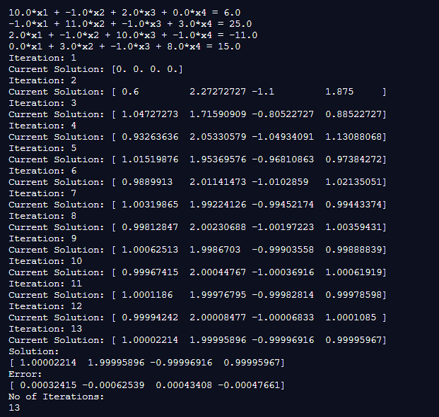

Q2:

|  |  |  |  |  |
| --- | --- | --- | --- | --- |
| S# | Functions | Tolerance | No.Of Iterations | Root |
| 1 | 83x+11y-4z=95  7x+52y+13z=104  3x+8y+29z=71 | 0.01 | 6 | x=1.05874766  y=1.37180339  z=1.96550715 |
| 0.001 | 8 | x=1.05800232  y=1.3675643  z=1.96202466 |
| 0.0001 | 10 | x=1.05793371  y=1.36719964  z=1.96171606 |
| 2 | 8x-3y+2z=45  4x+11y-z=71  6x+3y+12z=35 | 0.01 | 8 | x=7.3977288 y=3.61766817  z=-1.6785675 |
| 0.001 | 10 | x=7.40110315  y=3.60984686  z=-1.68693335 |
| 0.0001 | 12 | x=7.40029077  y=3.61017725  z=-1.6860157 |
| 3 | 10x1-1x2+2x3+0x4=6  -1x1+11x2-1x3+3x4=25  2x1-1x2+10x3-1x4=-11  0x1+3x2-1x3+8x4=15 | 0.01 | 8 | x1=0.99812847  x2=2.00230688  x3=-1.00197223  X4=1.00359431 |
| 0.001 | 10 | x1=0.99967415  x2=2.00044767  x3=-1.00036916  X4=1.00061919 |
| 0.0001 | 13 | x1=1.00002214  x2=1.99995896  x3=-0.99996916  X4=0.99995967 |